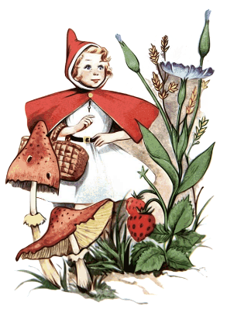
NEWSLETTER

St Patrick’s Nursery Unit Jan/Feb 2022
Theme: Fairy Tales and Nursery Rhymes
Colour: Red, Grey, White, Black and pastel shades
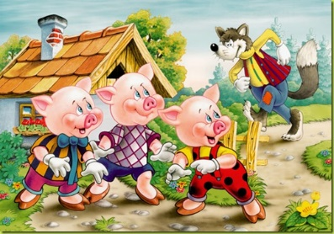
Rhymes and Stories

- Baa Baa Rainbow Sheep
- Humpty Dumpty
- Hickory Dickory Dock
- Little Red Riding Hood
- The Gingerbread Man

Dressing up Day

The children will have a celebration of nursery rhymes and Fairy tales on Wednesday 16th February when they can dress up as their favourite characters.

Mid Term Break
The Nursery will be closed from Thursday 17th – Monday 21st February (inclusive)

Birthday Greetings
Katie Arkinson 2nd Jan
Sophia Burke 7th Jan
This Photo by Unknown Author is licensed under CC BY-NC
Ollie McCullagh 12th Jan
Rylee Waugh 22nd Jan
Sophie McHugh 23rd Jan

Elsie McCrory 7th Feb
Cadain McNamee 17th Feb

Newsletters
All monthly correspondence will be posted on the school website. Please keep an eye out here at the beginning of each month. I will continue to text any further information via the Nursery Mobile.

Thank you for you continuing support and co-operation.

Yours Sincerely,

E. Shelley
Nursery teacher

