 St Patrick’s P.S.

and Nursery

Castlederg



**73 Castlefin Rd**

**Castlederg**

**Co Tyrone BT81 7EE**

**Tel 028816 71458 Fax 028816 79821 email:info@stpatricks.castlederg.ni.sch.uk**

**Website –** [www.stpatrickspscastlederg.co.uk](http://www.stpatrickspscastlederg.co.uk)

**January/February 2020 Newsletter**

**online @** [www.stpatrickspscastlederg.co.uk](http://www.stpatrickspscastlederg.co.uk)

**All Parents.**

On behalf of the staff, pupils and governors I wish to thank the Parents for the help and support they have provided all last term. £737 was raised in the Christmas Draw with £137 raised from the Christmas Card and Mug fundraiser. We have used this money to purchase new structured play equipment for our pupils in Nursery, P1 and P2. I am hopeful that with the re-establishment of the Assembly that our young people’s futures will be properly funded in the next financial year and in the years ahead.

The members of the local Society of the St. Vincent de Paul wish to thank the parents for their generosity in supporting the Christmas food appeal. The pupils also raised £169 on Christmas Jumper Day for the Children in Crossfire Lenten appeal. A lot of fundraising but for worthy causes – well done!

**Catholic Schools Week**



Catholic Schools Week will run from 26th January to 2nd February 2020. This year’s theme is Living in Harmony with God’s Creation. Throughout this week our pupils will learn about Living in Harmony with God, our neighbours, with all generations, with the earth and with each other.

Fr. Paul will celebrate a special mass for pupils in P4 to P7 to celebrate the work of our school on Friday 31st January 2020 at 10am in St. Patrick’s Church. (Weather Dependant*) We will also celebrate St Brigid’s Day on the 1st February 2020 and all our pupils look forward to Spring.

**P1 and Nursery Applications**

Please note that applications and documents for P1 and Nursery must be completed online at www.eani.org.uk by the 30th January 2020. Late applications cannot be considered until all other children are placed. Make sure all family members are informed.

**Meet Our Pupil Council 2020**

This is the 6th year of our Pupil Council. Our elected representatives are Eimear and Martha in P7, Niamh, Dana, Eadaoin and Farrah in P6 and Charlie, Emma and Isabella in P5. The Pupil Councillors meet with their classes to discuss issues affecting them – and report back to Mrs. Norton and Mr. Mc Gurk. They keep minutes of meetings and learn how a school council works and operates. Their opinions are valued by their classmates and by the staff. They hope to run competitions and discussions among their classmates. I have asked them to discuss Climate Change and to think of ways to raise awareness at school and at home.

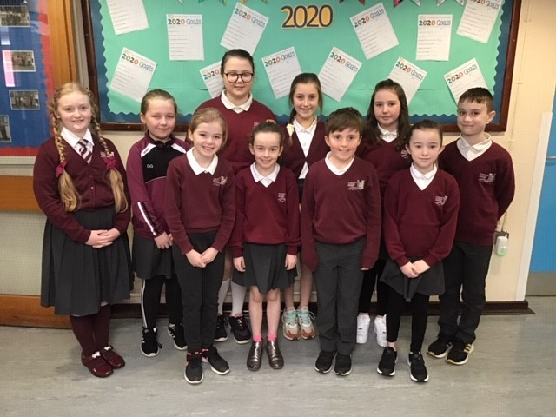

**World Book Day**

World Book Day takes place on Thursday 5th March 2020 so there be lots of opportunity for reading and storytelling during this week. Why don’t you make a special effort to visit the library this week or encourage the pupils to read during the month of March 2020. There are lots of activities and ideas on World Book Day Website - <https://www.worldbookday.com/>



‘The child who learns to read while sitting in Mum or Dad’s* lap will become a lifelong learner.’ – Bruce Perry



**Spelling Bee Competition /Science Projects.**

Mrs. Mc Erlean will be organising our annual spelling bee competition during March 2020 so children get practising.

Pupils in Mr. Keenan’s class and Mrs. Smith’s class take part in a Sentinus Science and Engineering Robotics Workshop on Wednesday 29th January 2020

**Extended Schools Spring Term 2020**

Breakfast club continues as normal each morning.

Sports clubs will resume in February.

* Homework Club Monday to Thursday 3.15pm – 4.30pm Cost £2 Daily.

Any changes or reasons for attendance should be recorded in the pupils reading record or homework diaries and the pupils can bring it to the attention of their teacher. Thank you.

**Safer Internet Day 11th February 2020.**



The school has participated in Internet Safety Day/Safer Internet Day since its inception in 2011.

This year’s theme is Together for a Better Internet. Further advice on online safety and tips for parents can be found at

<https://www.saferinternet.org.uk/advice-centre/parents-and-carers>

I’ll include this link and pupil links on our school website. We also post monthly online safety newsletters which are designed to help parents understand and keep their children safe online.

Remember it’s good to discuss with your child their internet use and to help them learn how to be safe. I would advise that pupils stay away from social media in primary school. Increasingly we are having to deal with unwanted comments and behaviours on social media which affects our pupils.

Remember children are not permitted to take phones or devices with bluetooth or cameras to school – including smart watches.

P7 Pupils will also take part in Workshops entitled ‘What’s Inside’ as part of the RSE Programme on the Friday 27th March 2020.

**Paired Reading Programme.**

Mrs. Mc Glade and Mr Keenan’s P3 classes are taking part in a paired reading programme from the beginning of February. More information is available from the class teachers.



**Gaelic games/sports**

The boys and girls football teams will compete in the Tyrone indoor gaelic competition in January and March 2019. Congratulations to Eoghain Bradley and Caitlin Gallen who represented the school at the Tyrone V Meath halftime mini-game on Sunday.

The P7 pupils will commence a ten week block of swimming lessons this week in swimming Riversdale Leisure Centre Strabane.

**Transfer Forms**

Transfer forms will be sent home this week with the P7 pupils, these have to be completed and returned to school by Tuesday 4th February 2020. If any parent wishes to arrange a meeting to discuss their choice of schools – please contact me at the numbers above.

**Healthy Snacks and lunch boxes**

As a health promoting school please include healthy foods in the children’s lunchboxes, also a reminder not to include nut products. Please remember that only healthy snacks can be eaten at break time, no chocolate or cereal bars, sweets or sugary yoghurts or drinks at break please. Your support is greatly appreciated.

**Midterm Holiday**

The school will be closed for the midterm break on Friday 14th February, Monday 17th February and Tuesday 18th February 2020.

The school will be closed for St Patrick’s Holidays on Monday 16th March and Tuesday 17th March 2020.

**Road Safety **

Thank you to all parent/s who park safely and who show care and consideration when dropping or collecting the pupils from school. Please avoid double parking as this causes a build-up of traffic and is dangerous for pupils at collection time. Please remember to keep clear disabled spaces and bus bays. Please remember to use only the main pedestrian gate to enter and exit the school.

Older pupils may bring their bicycle to school safely. Remember they must have a helmet if they are cycling to and from school.

Many thanks. Brian Mc Gurk Principal