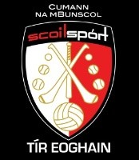

Match Report /Press Release - The Allianz Cumann na mBunscol Tir Eoghain Gaelic Football Round 1 section L

The Allianz Cumann na mBunscol Tir Eoghain Gaelic Football Round 1 section L heat took place in glorious sunshine in Strabane Sigersons beautiful pitch on Tuesday 26th April. The larger schools in Strabane /Castlederg areas compete in this section – St Mary’s PS Melmount Strabane, St Catherine’s PS, St Mary’s Cloughchor and St. Patrick’s PS Castlederg.

This was the first time in 2 years that the Allianz Cumann na mBunscol Tir Eoghain outdoor sections were able to be held with the children and school staff greatly enjoying the day.

The boys section was fiercely contested with St Patrick’s PS Castlederg and St Mary’s PS Cloughchor occupying the top 2 spaces.

The girls from St. Catherine’s PS and St. Patrick’s PS are tied after 2 competitive matches and a section winner will be decided at the next heat.

Tyrone County Board Coach and Gortin Naoimh Padraig GAC player Fiachra Mc Nulty was on hand to assist on the day and it was great to see teachers and club players coaching on the day - with Mr. Danny Mc Bride Strabane Sigersons coaching St Mary’s Melmount, Mr. Cahill Logue Castlederg Naoimh Eoghain GAC coaching St Catherine’s Strabane and Ruiari Keenan Gortin Naoimh Padraig GAC coaching St. Patrick’s PS Castlederg.

Round two of this Allianz Section will take place in Owen Roe’s GAC on Monday 16th May 2022 with winners in the boys and girls competitions going ahead to compete in the Allianz Cumann na mBunscol Tir Eoghain Finals Day on Wednesday 8th June at Tyrone GAA Garvaghey.

[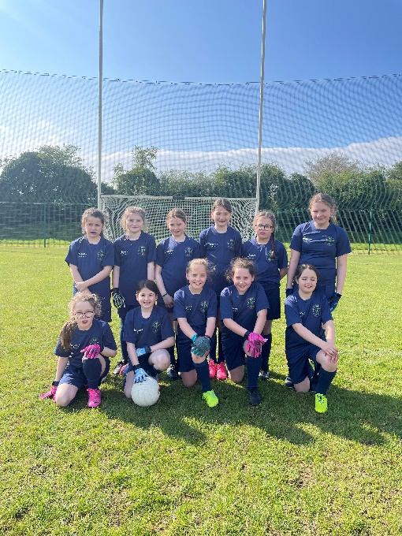](https://aka.ms/o0ukef)  
St. Catherine’s PS Strabane Girls Team

[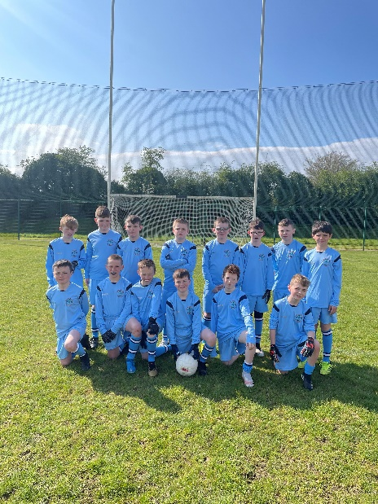](https://aka.ms/o0ukef)

St Catherine’s PS Boys Team

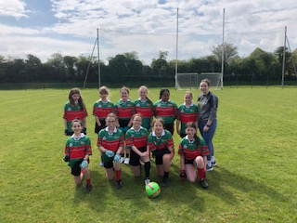

St. Patrick’s PS Castlederg Girls Team

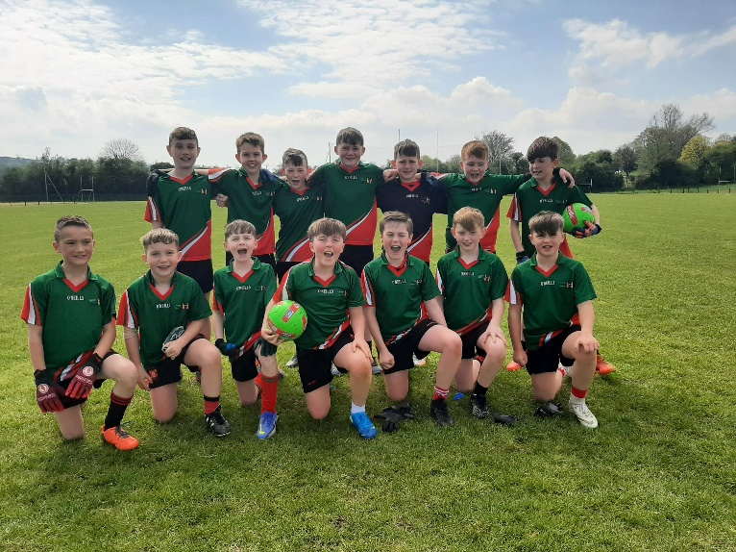

St. Patrick’s PS Castlederg Boys Team

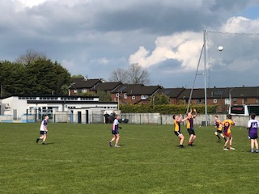

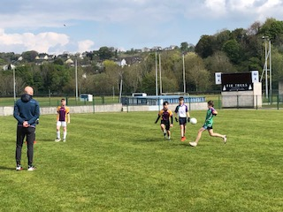

1 /2 Action from St Mary’s PS Cloughchor V St Mary’s PS Melmount Match

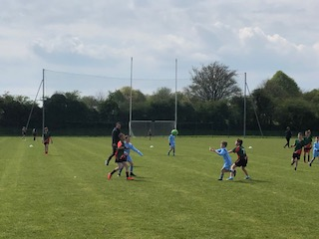

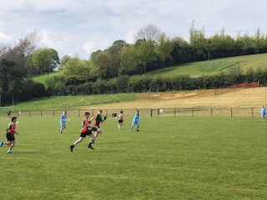

3/4 Action from St. Patrick’s PS Castlederg V St. Catherine’s PS Strabane

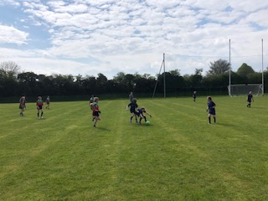

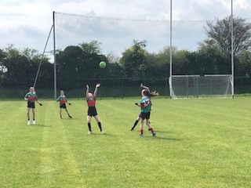

5/6 Action from St. Patrick’s PS Castlederg V St. Catherine’s PS Strabane

Brian Mc Gurk Principal St. Patrick’s PS Castlederg /Section Co-ordinator